For Lease

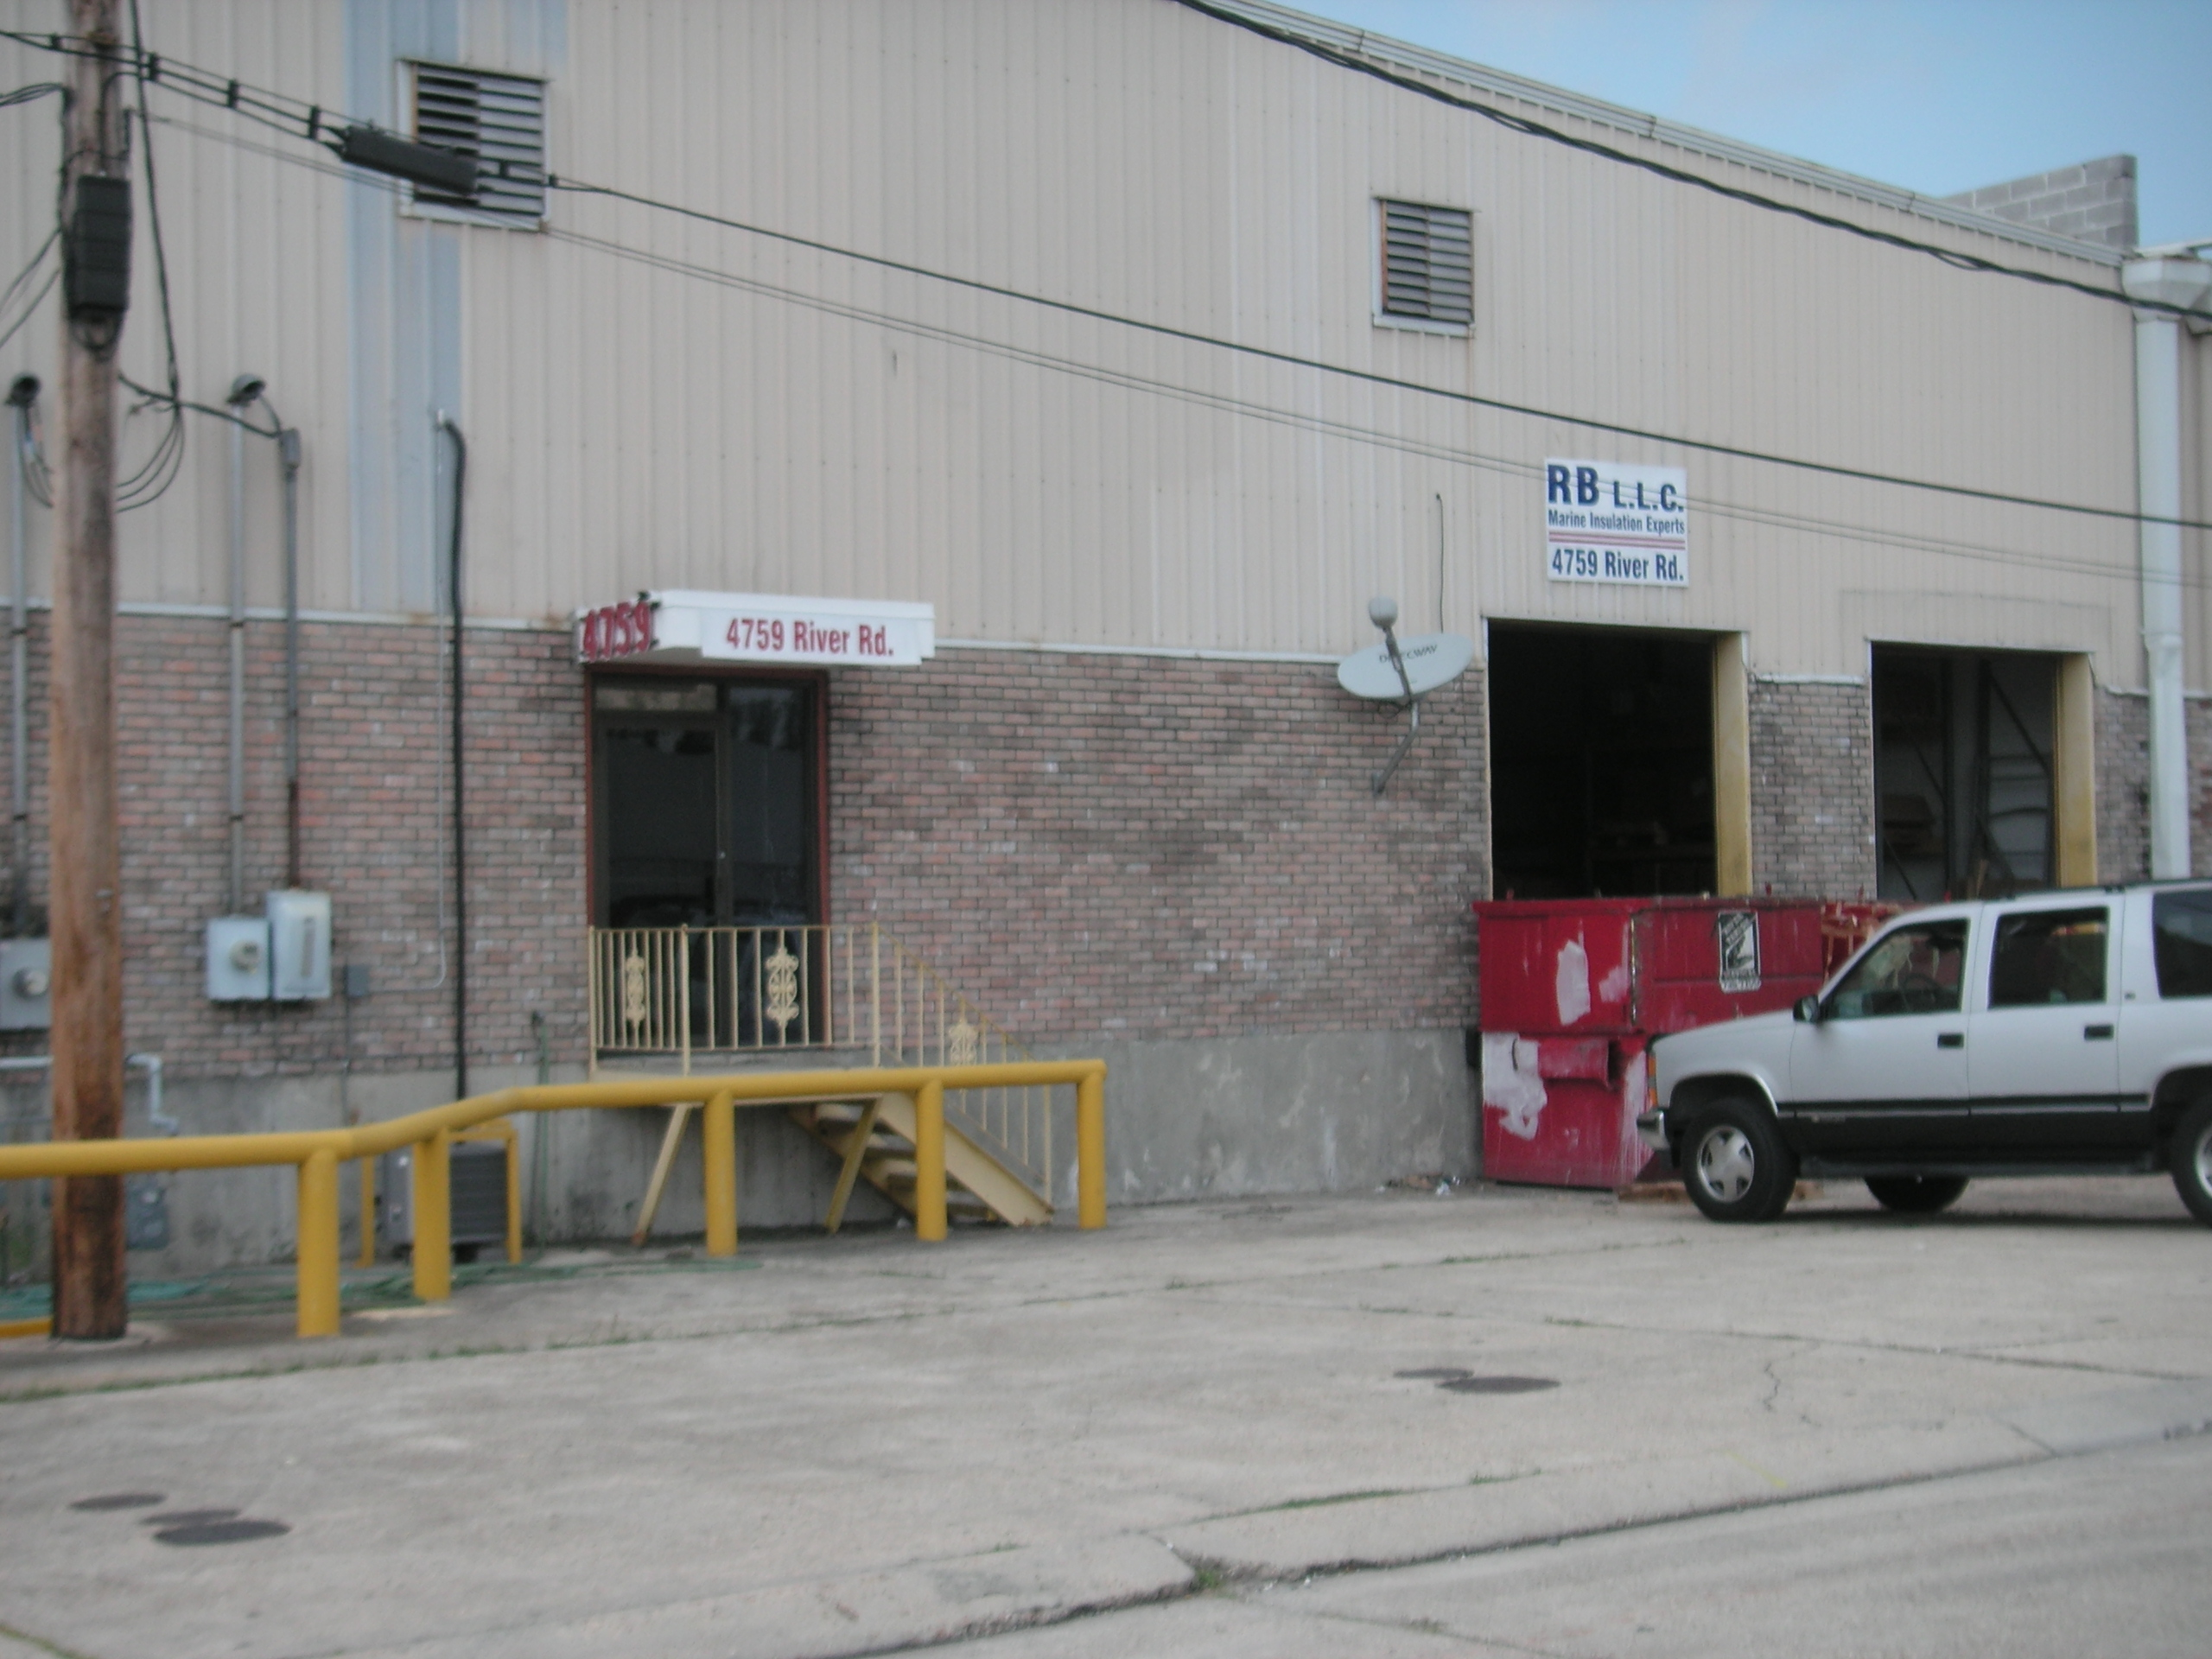

4759 River Road, New Orleans, LA 70121

Building: 7,500 Square Feet Construction: Brick, Block & Metal

Office: 775 Square Feet Loading: (2) 9’x10’ Dock Doors

Parking: Off Street Eave Height: 20’

Yard Area: No Skylights: Yes

Warehouse Heaters: Yes Sprinkler: Yes

Lease Price: $4,062.50 per mo. ($6.50 psf) Net

2022 Taxes: $4,356.21 – ($363.02 per mo.) $0.58 psf

2023-24 Insurance: $6,379.08 - ($531.59 per mo.) $0.85 psf

CAM: $477.86 - ($39.82 per mo.) $0.06 psf

TOTAL PER MONTH: $4,996.93

Further Information: Randall Walker, SIOR
The Industrial Group
1504 L & A Road
Metairie, LA 70001
(504) 832-8012
Randall@igreal.com
Licensed By the Louisiana & Mississippi Real Estate Commissions
Licensed By The Louisiana State Licensing Board of Contractors.



7/30/2026

